# ViewModel Diagram

1. Meeting Request 2.5

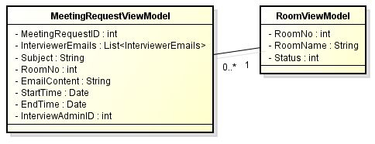

1. Report 2.9

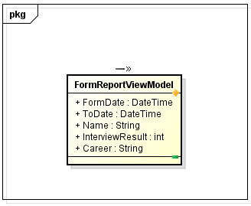

# Controller Diagram

1. Meeting Request 2.5

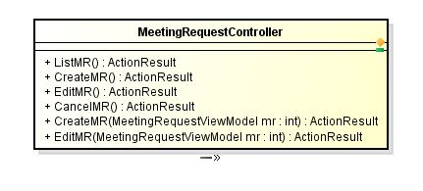

1. Report 2.9

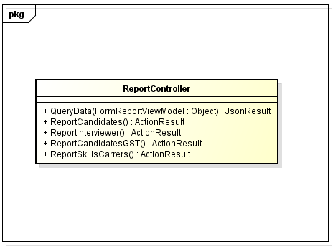

# Entity Diagram

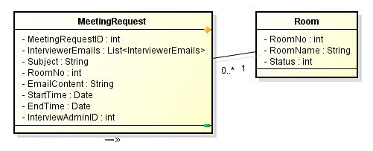

# Class Business Diagram

1. Meeting Request 2.5

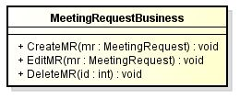

1. Report 2.9

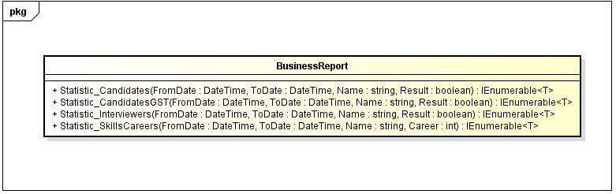

# Class Service Diagram

1. Meeting Request 2.5

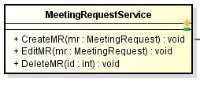

1. Report 2.9

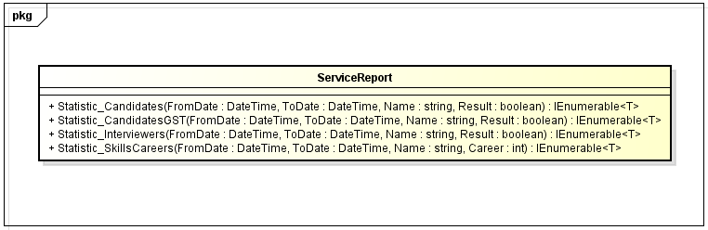

# Class Repository Diagram

1. Meeting Request 2.5

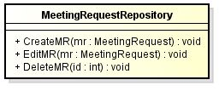

1. Report 2.9

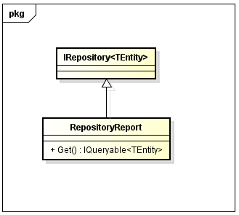

# Class Diagram

1. Meeting Request 2.5

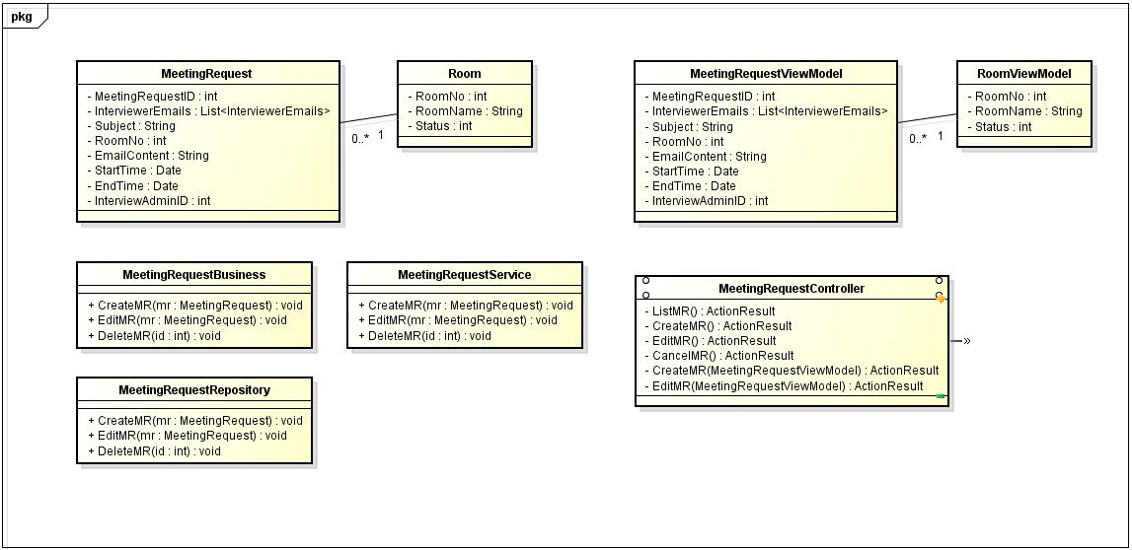

1. Report 2.9

